**Assignment – 3**

1. The following figure shows an ER schema for a database that can be used to keep track of transport ships and their locations for maritime authorities. Map this schema into a relational schema and specify all primary keys and foreign keys.

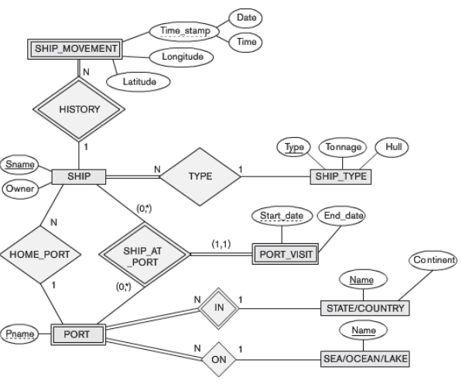

1. Notown Records has decided to store information about musicians who perform on its albums, as well as other company data, in a database.

* Each musician that records at Notown has an SSN, a name, an address, and a phone number. Poorly paid musicians often share the same address, and no address has more than one phone.
* Each instrument used in songs recorded at Notown has a name (e.g. guitar, synthesizer, flute) and a musical key (e.g. C, B-flat, E-flat).
* Each album recorded on the Notown label has a title, a copyright date, a format (e.g. CD or MC), and an album identifier.
* Each song recorded at Notown has a title and an author.
* Each musician may play several instruments, and a given instrument may be played by several musicians.
* Each album has a number of songs on it, but no song may appear on more than one album.
* Each song is performed by one or more musicians, and a musician may perform a number of songs.
* Each album has exactly one musician who acts as its producer. A musician may produce several albums.

Draw the ER diagram for the database design. Convert the ER diagram to relations.

1. Consider the following EER diagram for a car dealer. Map the EER schema into a set of relations. For the VEHICLE to CAR/TRUCK/SUV generalization, consider the four options (8A, 8B, 8C and 8D) and show the relational schema design under each of those options.

